**Single linked list**

* 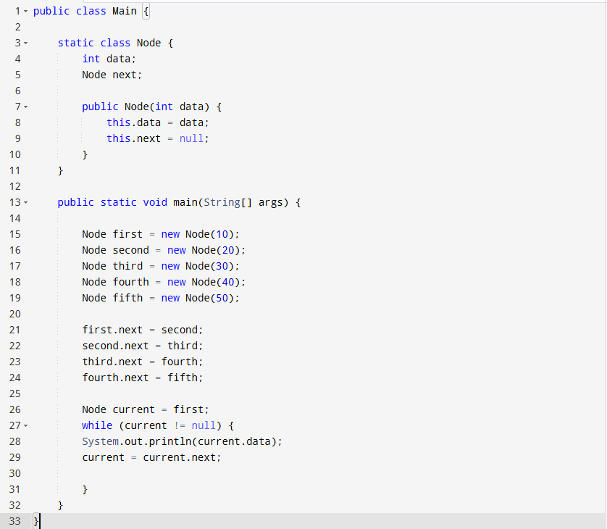a single link list is a list with nodes, each node has a data field and a reference to the next node.

**Doubly linked list**

* 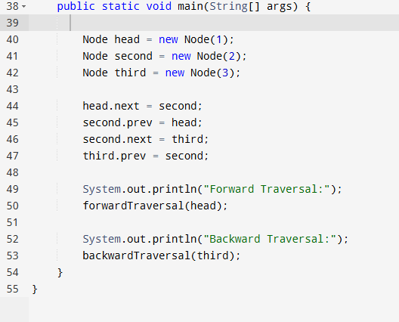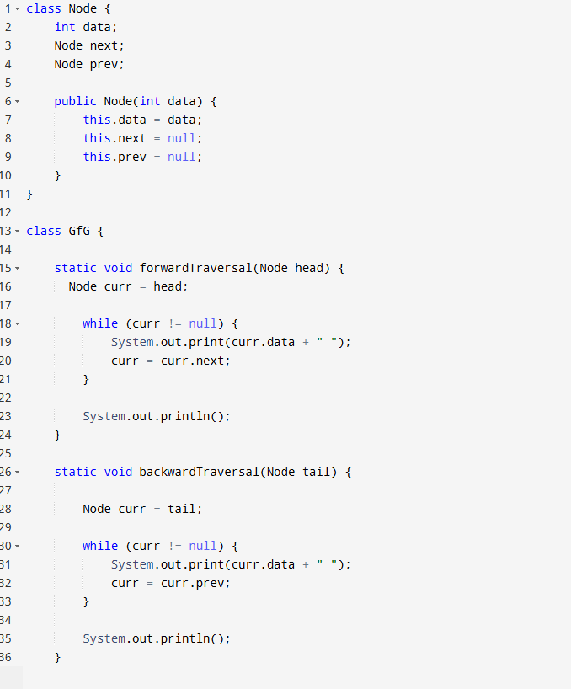this list is as same as the Singly but can be forward or backward Traversal

**Circular linked list**

* 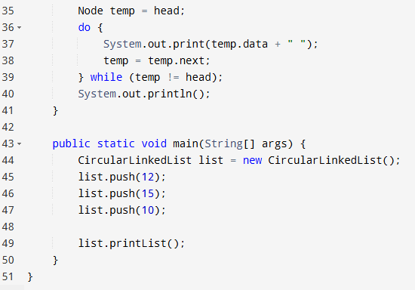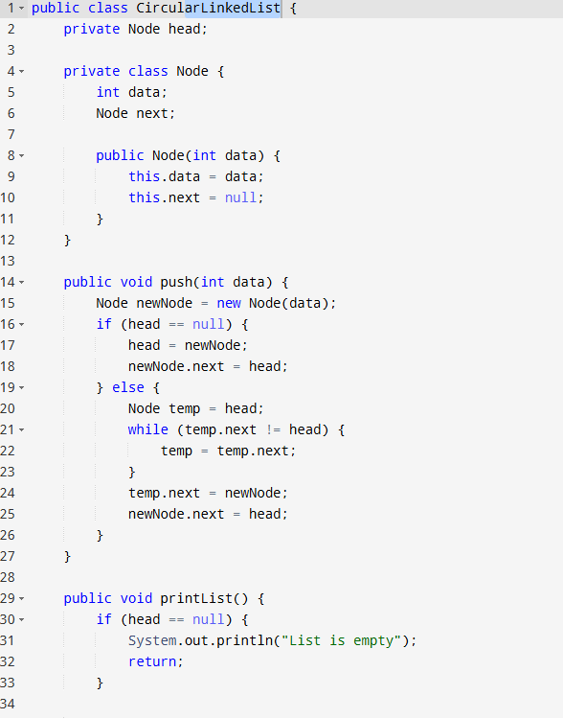it is as same as the singly but doesn’t end with null instead it goes back to the first node

**Doubly Circular List**

* 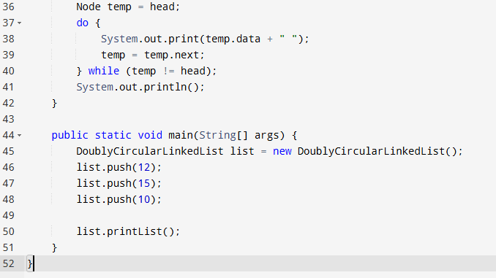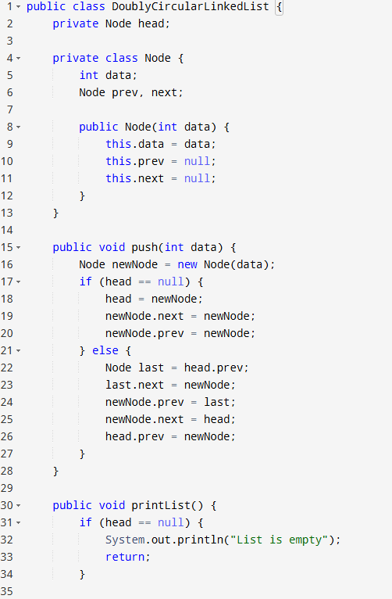is as same as a doubly link list but can traverse backward and forward with no end, the first node storing the address to the last node, the last node storing the first node